|  |  |  |  |
| --- | --- | --- | --- |
| **Course Name:** | **Elements of Electrical and Electronics Engineering** | **Semester:** | **I** |
| **Date of Submission:** | **15 / 12/ 2021** | **Batch No:** | **A3** |
| **Faculty Name:** |  | **Roll No:** | **070** |
| **Faculty Sign & Date:** |  | **Grade/Marks:** | **/ 20** |

1. **Electrical power Generation and distribution systems:**

**List the Electrical power generation methods in India. Explain using a block diagram how electricity reaches at your home from generating station. Explain in brief the stages of conversion of Voltages and the role of the transformer.**

**Ans:** India is the world’s third-largest producer and third-largest consumer of electricity. The national grid in India has been installed of capacity 373.029Gw in the month of 30 September 2020. The major source of power generation in India is coal, natural gases which provide almost 59.7%of countries power needs. The Overall generation in the country has been increased from 1048.673 during 2014-15 to 1107.386 BU* during the year 2015-16. The Category wise generation performance is as follows:- Thermal Increased by 7.45 %, Hydro Reduced by 6.09

%, Nuclear Increased by 3.63 %. The overall leader of electricity generation in India is thermal power (68%) of total power generation in India. India mostly depends on coal for its power usage. Coal reserves are concentrated in Jharkhand, Orissa, West Bengal, Chhattisgarh, parts of Madhya Pradesh, whereas lignite is located in Tamil Nadu and Gujarat. North Eastern Region, and Sikkim.

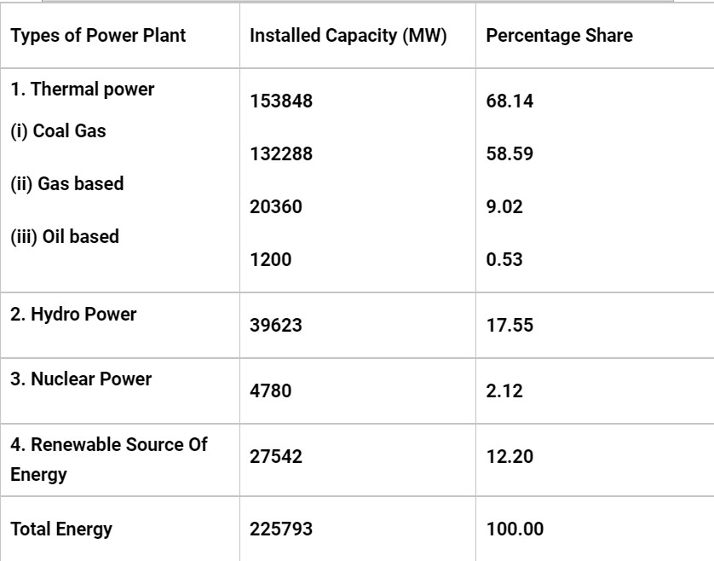

Fig. 1

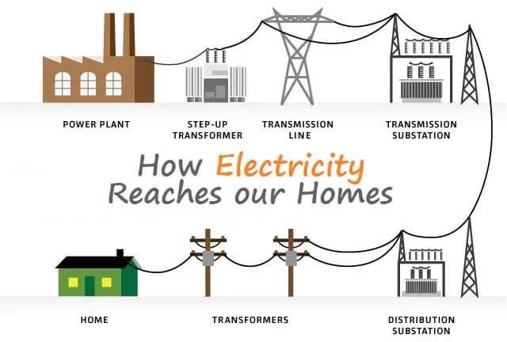

Fig. 2

When power is generated in power station it is generated at 11Kv but to transport electricity over large distance the voltage must be high hence a transformer is used to increase its voltage up to 300Kv.After the power is transmitted over large distance before enteringthe houses a substation reduces the voltage and hence it is directed towards residential area And finally the transformer on the pole reduces the voltage to the level which is suitable for the household use and this is the current which is suitable for the appliances at house and commercial building. According to this we need three step-down transformer.

There are three times voltage is stepped down using transformer. Electricity is generated in power station by burning coal which produce energy is produce which henceforth rotates the big turbines, due to the rotation of the turbine mechanical energy is produce and this mechanical energy is transformed to electrical energy by using various machines. This power is at a low voltage about 11kv to33kv, but to transmit this electricity to long distances voltage should be high hence a voltage step up transformer is used to increase the voltage to 100Kv-700Kv depending on the distance. We need to provide high voltage to prevent the loss of energy. In some parts of India, underground cables are also used in cases where transmission takes place over a shorter distance. This is called primary transmission.

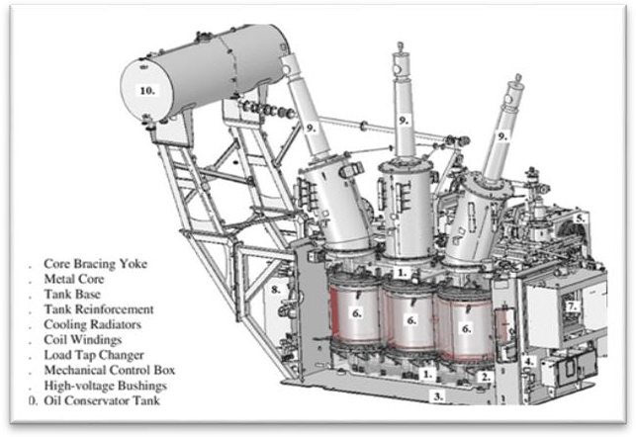

Fig. 3

When the power reaches the receiving substation the voltage stepped down to 33Kv-66Kv, the current is transmitted through the power lines emerging from the substation and send towards cities, villages, industries and suburbs. When electrical power reaches a substation, it is stepped down once more by a step-down transformer to voltages closer to what it was generated at—usually around 11kV. This current can now be transmitted to residential area. This is called secondary transmission.

* Transformer help to improve safety and efficiency of power system by rising and lowering the voltage of the current as per our needs. They are have a wide application in residential and industrial, primary and perhaps the most important of all distribution and regulations of power across over large distance.
* In the transformer, there is no moving part to transfer electricity which means there is no loss of energy in the friction hence no wind age loss but we cannot say that the transfer which are been use are 100% efficient because there is loss in copper and iron losses.
* Transformer works on the principle of mutual inductance the core of the transformer is usually made of soft iron because the iron core prevents the scattering of the electric field. The transformers which are being used are 96%-98% efficient.
* Without the transformer, we would not be able to send power over a large distance through a wire. Hence invention transformer is one of the largest discoveries of mankind.

# List the possible electrical Hazards inside a home?

Ans:

1. Poor wiring and defective wiring:

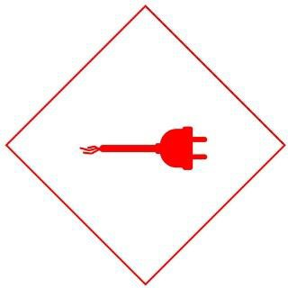

Poor wiring can increase the chance of fire, power surges, and arc faults with other dangerous consequences. Poor wiring can also increase the chance of an electrical accident. Hence it is necessary to do your wiring with good quality wire and from an electrical professional.

1. Outlets close to water:

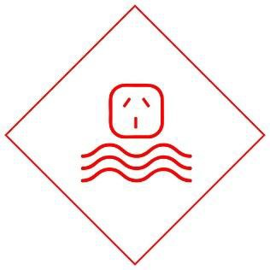

Outlets in bathroom, kitchen, and living room should be kept away from the water source as water is a good conductor of electricity if kept near an outlet my lead to electric show which can be harmful and may sometimes lead to death and also never use electrical appliances when near water.

1. Extension cord

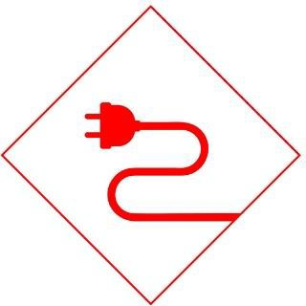

Extension cord should be carefully place where it reduce the chance of tripping. We should not use extension cord as permanent for additional power socket, and avoid using it for more appliances at once.

1. Pouring water on an electrical fire

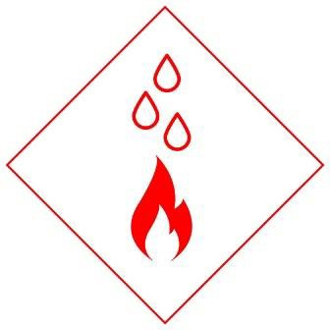

The most common mistake people make is to put water on an electrical fire, avoid putting water on electrical fire as it make increase the fire’s intensity. If you are afraid about electrical fire always keep a fire extinguisher in site. Never use water on electrical fire.

1. Light Bulbs

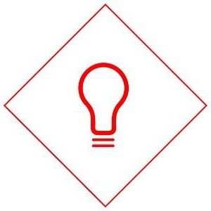

We don’t often think of lightbulbs as being electrical hazards, but the potential for an electrical fire arises when lightbulbs are kept near flammable materials. These can include beds, drapes, plastics, or other items such as upholstery. Lights, like all sources of electricity, can also cause electric shock, so ensure you always turn the light switch off before replacing a light bulb, and never replace a light bulb or touch a light switch with wet hands.

1. **Electrical safety essentials: List and brief about Products for a safer home such as Circuit barkers, MCBs, Switch Fuse Unit (SFU, ELCB, MCCB. (Note: Students can add photographs of safety devices)**

Ans:

Circuit breakers:

Circuit breakers are devices that protect circuits from overload current conditions. They do the same job as fuses, but they are not destroyed when activated as for fuse it is completely destroyed. They are more expensive to put in than fuses but since components rarely need to be replace, circuit breakers functions as an open switch which turnoff all the current before excess electrical current start a fire. There are various type of circuit breaker like MCB (miniature circuit breaker), MCCB (Modules case circuit breaker), Air circuit breaker, Vacuum circuit breaker, RCCB (Residual current circuit breaker). These are the various types of circuit breaker with their own unique properties and functions.

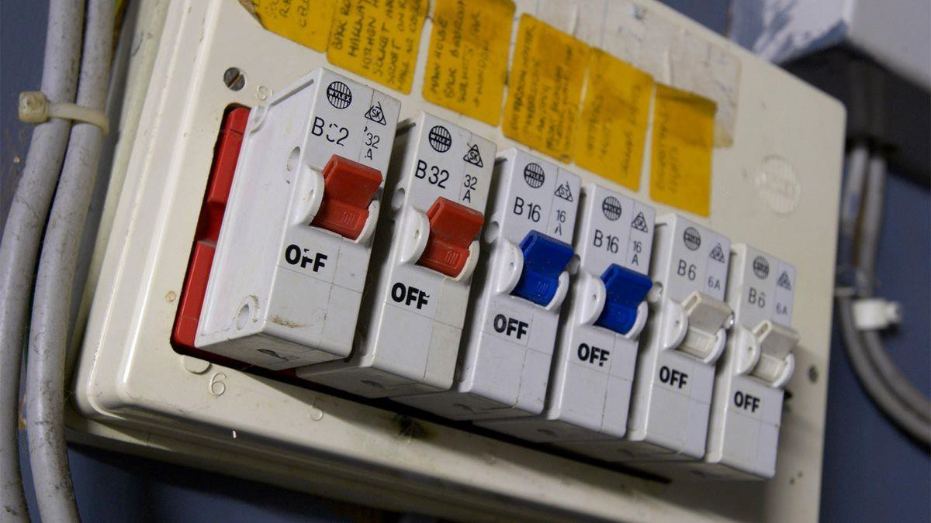

Fig. 4

MCB(Minature circuit breaker) :

An MCB is an automatically operated electrical switch. Miniature circuit breakers are intended to prevent damage to an electrical circuit as a result of excess current. They are designed to trip during an overload or short circuit to protect against electrical faults and equipment failure. MCBs are widely used as isolating components in domestic, commercial, and industrial settings. They form part of a broader family of more powerful [circuit-breaking components](https://uk.rs-online.com/web/c/automation-control-gear/circuit-protection-circuit-breakers/).

MCB works on bipolar respective which provide protection against overload current and solenoid short circuit current. The other feature of MCB is rated current, not more than 125 amperes, its trip characteristic is normally not adjustable since it basically caters to low circuits.

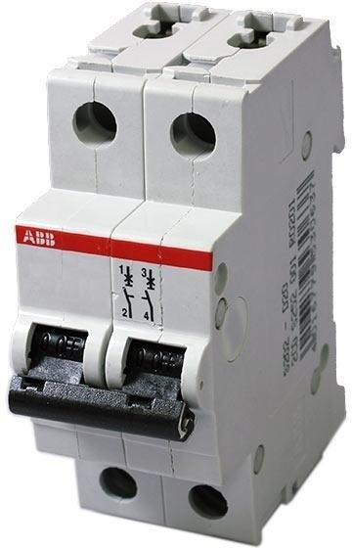

Fig. 5

SFU(Switch fuse unit):

SFU stands for switch fuse unit. SFU contains one switch unit and one fuse unit. The contact will get closed through the switch and then the supply will pass through the fuse unit in the output. Normally we use an HCR fuse in this kind of unit. We can select a suitable fuse rating based on the connected load. As technology developing SFU's are getting replaced with advanced MCCB's molded Case Circuit Breaker)

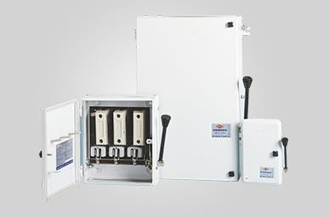

Fig. 6

ELCB(earthing leakage circuit breaker):

An ECLB is one kind of safety device used for installing an electrical device with high earth impedance to avoid shock. These devices identify small stray voltages of the electrical device on the metal enclosures and intrude the circuit if a dangerous voltage is identified. The main purpose of the Earth leakage [circuit breaker](https://www.elprocus.com/how-circuit-breakers-work/) (ECLB) is to stop damage to humans & animals due to electric shock. An ELCB is a specific type of latching relay that has a structure’s incoming mains power associated through its switching contacts so [that the circuit breaker](https://www.elprocus.com/how-circuit-breakers-work/) detaches the power in an unsafe condition. There are 2 types of ELCB voltage operated and Current operator which is known as RCCB. Both ELCB have their unique property.

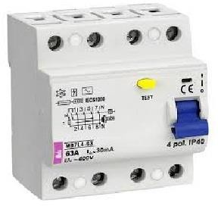

Fig. 7

MCCB (Molded Case Circuit Breaker).

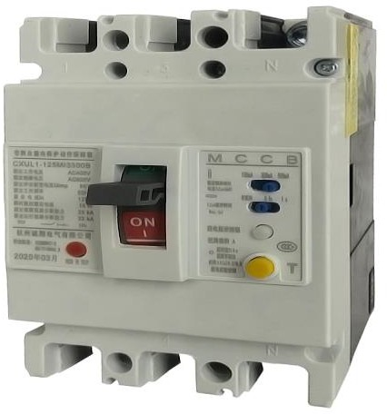

Fig. 8

MCCB is used for 250 amps to 800 amps in the motor feeders. This system of circuit breaker basically protects the entire electrical system from overloading and having such conditions of short circuit issues. To simply put it these are the electrical protection gadgets that are used mostly with a wide range of voltages as MCCB which are commonly known have adjustable trip settings and can hold as much as 2500 amps in current ratings.

# What are the Types of Wires and Cables used for electricity distribution?

Ans: There are various types of wire and cables which are been used for transmitting various types of signals the types of wires which are used are:

* 1. Coaxial cable used for radio frequency signals, for example in cable television distribution systems,
  2. Communication cable,
  3. Direct buried cable,
  4. Flexible cable,
  5. Helix cable,
  6. Non-metallic sheathed cable (or non-metallic building wire, NM, NM-B),
  7. Metallic sheathed cable (or armored cable, AC, or BX),
  8. Multicore cable (consist of more than one wire and is covered by cable jacket),
  9. Paired cable – Composed of two individually insulated conductors that are usually used in DC or low-frequency AC applications,
  10. Portable cord – Flexible cable for AC power in portable applications,
  11. Ribbon cable – Useful when many wires are required. This type of cable can easily flex, and It is designed to handle low-level voltages,
  12. Shielded cable – Used for sensitive electronic circuits or to provide protection in high-voltage applications, Single cable (from time to time this name is used for wire),
  13. Submersible cable-These are placed deep in the ocean through which international transmission takes place,
  14. Twin-axial cable,
  15. Twin-lead – This type of cable is a flat two-wire line. It is commonly called a 300 Ω line because the line has an impedance of 300 Ω. It is often used as a transmission line between an antenna and a receiver (e.g., TV and radio). These cables are stranded to lower skin effects,
  16. Twisted pair – Consists of two interwound insulated wires. It resembles a paired cable, except that the paired wires are twisted. To transmit electric current in residential are we use high tension line which is placed overhead a certain height.
  17. Underground Feeder Cable,
  18. Triplex wires,
  19. Main Feeder Wires,
  20. Panel Feed Wires
  21. Single Strand Wires
  22. Non-Metallic Sheathed Wires
  23. Recently a new type of cable is been used for transmission of electricity and communication signals. These are known as optical fibre which is the fastest way to transmit electricity and signal, but it is the most expensive cable compared to others. Optical fibre works on the principle of refraction and there is least to no loss of signal and electricity.

1.

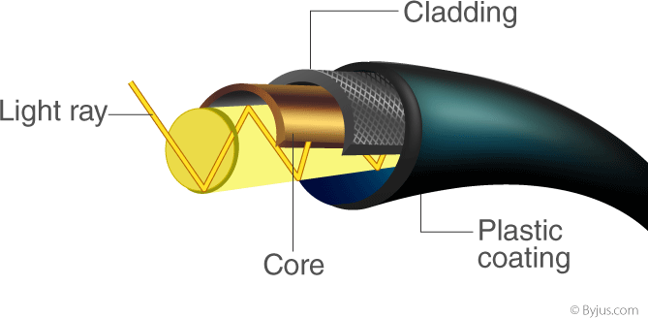

* + 1. Fig. 9 Optical Fibre

# Importance of Earthing?

Ans: Earthing is a connection between electrical devices to the earth through a low resistance path, which provides a discharge of the electrical energy directly to the earth. Considering the safety reasons earthing is one of the main safety requirement in an electrical system.

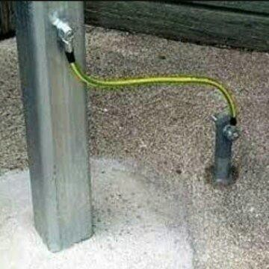

Fig. 10 - Earthing

* Minimizes risk of electric shock: The main purpose of earthing is to avoid or minimize the chance of electrocution. Any leakage or faulty current in the circuit causes the presence of electric charge on exposed conductive surfaces. Earthing provides a low resistive conductive path directly to the earth, which carries any such fault or leakage current.
* Dissipation of static charge: In a perfectly earthed system its potential remains approximately equal to zero. So it can remove most of the static charge build-up in the conductors.
* Protection from power surges: Earthing can protect from sudden excessive surges, it also provides protection from lightning strikes. Any lighting strikes on the exposed metal or received through another path which is connected to earth line get discharged directly to earth.
* For proper functioning of equipment’s: Proper earthing is very important for the functioning of the devices connected to the system. Mainly protective devices like ELCB, earth fault relays, etc. needs proper earthing for its functioning. Because in order to operate all these devices use the reference of leakage current through the earth line.
* Voltage Stabilization: In a network which has multiple feeders or sources there must be a common point which acts as a universal reference point. The Earthing acts like as a balance point.

# Explain in brief fluorescent, CFL, LED operations and typical power ratings. ?

Ans:

# Fluorescent light:

Fluorescent lamp was invited Cooper Hewitt In the year 1927. A fluorescent lamp is a low weight mercury vapor lamp that uses fluorescence to deliver visible light. An electric current in the gas energizes mercury vapor which delivers ultraviolet radiation through discharge process and the ultraviolet radiation causes the phosphor coating of the lamp inner wall to radiate visible light. A fluorescent light has changed useful electrical energy into light energy with more efficient and without wasting excess energy in heat energy compared to incandescent lamps. The normal luminous viability of fluorescent lighting frameworks is 50 to100 lumens per watt.

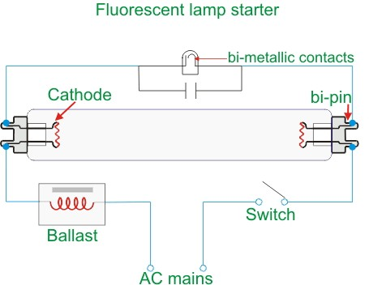

Fig. 11

Working:

When we switch ON the supply, full voltage comes across the lamp and as well as across the starter through the ballast. But at that instant, no discharge happens, that means no lumen output from the lamp. At that full voltage first the glow discharge is established in the starter. This is because the electrodes gap in the neon bulb of starter is much lesser than that of the fluorescent lamp. Then gas inside the starter gets ionized due to this full voltage and heats the bimetallic strip. That causes to bend the bimetallic strip to connect to the fixed contact because of that current starts to flows. Although the ionization potential of the neon is more than that of the argon but still due to small electrode gap, a high voltage gradient appears in the neon bulb and hence glow discharge gets started first in the starter. As soon as the current starts flowing through the touched contacts of the neon bulb of the starter, the voltage across the neon bulb gets reduced since the current, causes a voltage drop across.

Gas discharge process gets started and continues and hence current again gets a path to flow through the fluorescent lamp tube (tube light) itself due to this discharge of mercury atom takes place and release an ultraviolet light which triggers the atoms of phosphor which in turn emits visible light. This the complete working of fluorescent light. They are the most commonly used light source to light up a room, classroom. Two power rating most common types are 40-watt, 4-foot (1.2-meter) lamps, and 75-watt, 8-foot (2.4-meter) lamps.

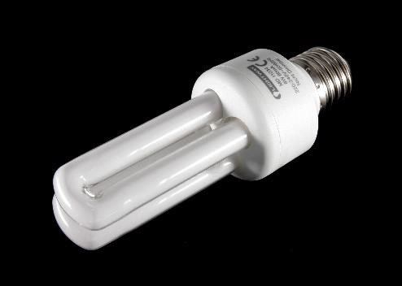

Fig. 12 – Fluorescent Bulb

# LED (light emitting diode):

The Light emitting diode is a two-lead semiconductor light source. In 1962, Nick Holon yak has come up with an idea of light emitting diode, and he was working for the general electric company. The LED is a special type of diode and they have similar electrical characteristics of a PN junction diode. The lighting emitting diode is a p-n junction diode is a specially doped diode and made up of a special type of semiconductors. When the light emits in the forward biased, then it is called as a light emitting diode.

Working:

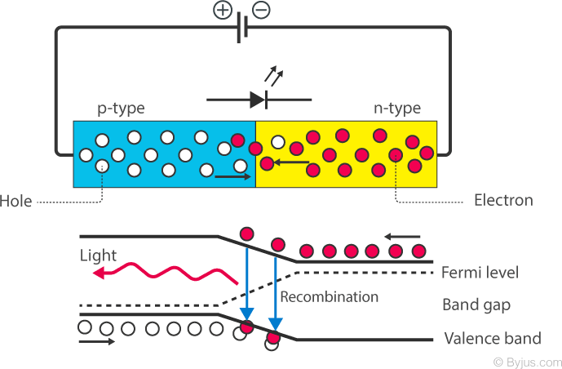

Fig. 13

When the diode is forward biased, the minority electrons are sent from p → n while the minority holes are sent from n → p. At the junction boundary, the concentration of minority carriers increases. The excess minority carriers at the junction recombine with the majority charges carriers. The energy is released in the form of photons on recombination. In standard diodes, the energy is released in the form of heat. But in light-emitting diodes, the energy is released in the form of photons. We call this phenomenon electroluminescence. Electroluminescence is an optical phenomenon, and electrical phenomenon where a material emits light in response to an electric current passed through it. As the forward voltage increases, the intensity of the light increases and reaches a maximum.

LED are used in various places like used as a bulb in the homes and industries, at the traffic light signals led’s are used, and also used in cars and bike. The typical power rating can a voltage of an LED is between 1.8 and 3.3 volts. It varies by the color of the LED. A red LED typically drops around 1.7 to 2.0 volts.

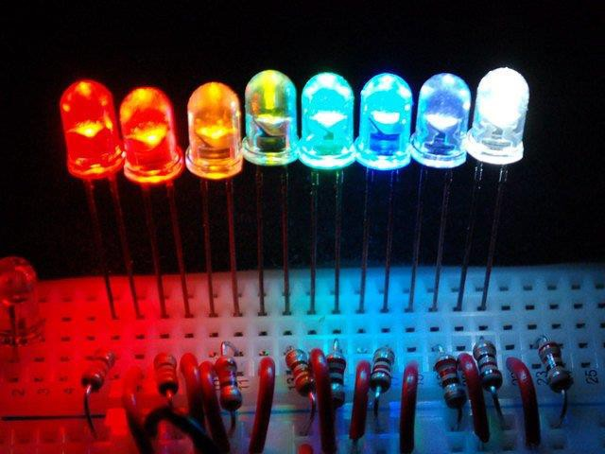

Fig. 14 - LEDs

# CFL (compact Fluorescent light):

The term ‘CFL’ stands for Compact Fluorescent Lamp. It is also known as compact fluorescent light, energy-saving light, and compact fluorescent tube. This was design to replace incandescent light in terms of efficiency and power consumption, CFL consists a tube which is curved/spiraled to fit into the space of an incandescent bulb, and a compact electronic ballast in the base of the lamp.

Working:

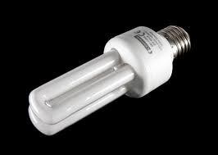

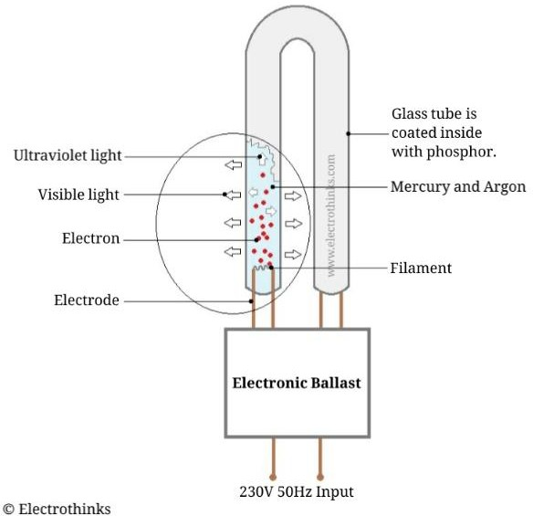

Fig. 15 Fig. 16 – CFL Blub

Compact arc tube of a lamp contains a high-pressure mixture of argon and mercury. Like ordinary fluorescent tubes, in this case, also, the light is produced by passing an electric arc through a mixture of these gases. The ballast used provides proper starting and operating voltages and regulates the current flow in the lamp.

Increasing use of electronic ballasts has removed most of the flickering and slow starting traditionally associated with fluorescent lighting. Compact fluorescent lamps generally radiate a different light spectrum from that of incandescent lamps. However, nowadays with the improved phosphor formulations, the lamps emitting soft white light similar in color to standard incandescent lamps are also available.

The CFL also consists a switched-mode converter. It functions on a very high frequency and acts as a replacement for ballast (choke) and starter assembly. The advantage of CFL is that it more efficient than an incandescent bulb, it has a higher life span (nearly ten to fifteen times) compared to the old filament bulbs. It has a lesser power rating (almost 80 percent) compared to the old filament bulbs. The typical power rating of CFL is about only 12-16 watts compared to similar incandescent bulbs.

**BIBLIOGRAPHY**

* <https://electricalfundablog.com/how-electricity-reaches-our-homes/>
* [https://www.jagranjosh.com/general-knowledge/sources-of-power-](https://www.jagranjosh.com/general-knowledge/sources-of-power-generation-in-india-1468231428-1) [generation-in-india-1468231428-1](https://www.jagranjosh.com/general-knowledge/sources-of-power-generation-in-india-1468231428-1)
* [https://www.platinumelectricians.com.au/blog/8-dangerous-home-electrical-](https://www.platinumelectricians.com.au/blog/8-dangerous-home-electrical-hazards/) [hazards/](https://www.platinumelectricians.com.au/blog/8-dangerous-home-electrical-hazards/)
* https://energyeducation.ca/encyclopedia/Electrical_safety_deviceshttps://uk.r s-online.com/web/generalDisplay.html?id=ideas-and-advice/mcb-guide
* [https://www.elprocus.com/working-principle-of-earth-leakage-circuit-](https://www.elprocus.com/working-principle-of-earth-leakage-circuit-breaker-elcb/) [breaker-elcb/](https://www.elprocus.com/working-principle-of-earth-leakage-circuit-breaker-elcb/)
* <https://mechatrofice.com/electrical/earthing-importance>
* <https://www.slideshare.net/DANIELMANOJ1/electrical-installations>
* <https://www.electrical4u.com/fluorescent-lamp-its-working-principle/>
* <https://byjus.com/physics/light-emitting-diode/>
* <https://electricalworkbook.com/compact-fluorescent-lamp/>